EShare for Android Manual
- Install EShare app to Android device
Make sure your Android device and the large-screen device are connected to the same network, open "EShareServer" on large-screen device. And then press the prompt on the page, Scan the QR Code on the Android phone or visit the download URL, download and install "EShare for Android".
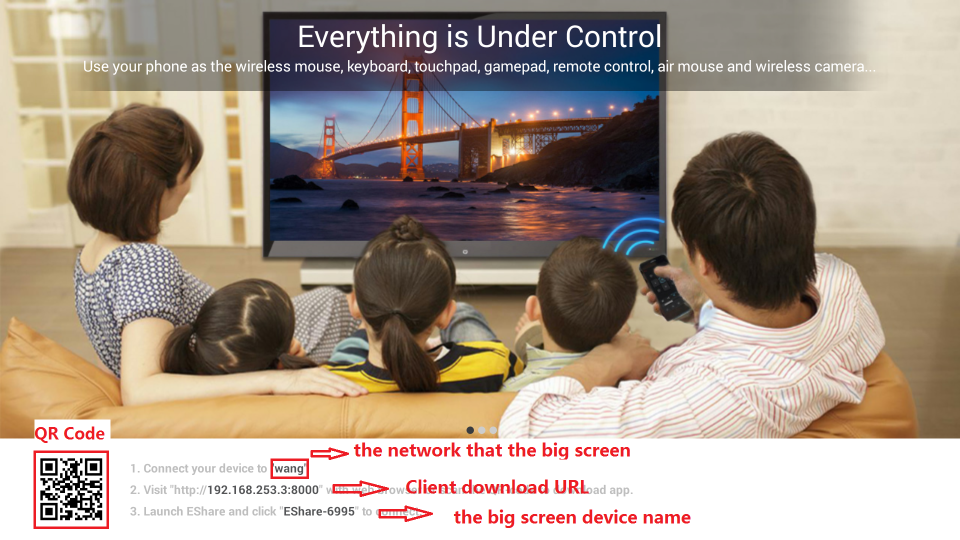
- Connect with the large-screen device
After EShare installed, open the "EShare" application on your phone, at this point EShare will automatically search large-screen devices on the same network. In the device list, click the large-screen device you want to connect to.
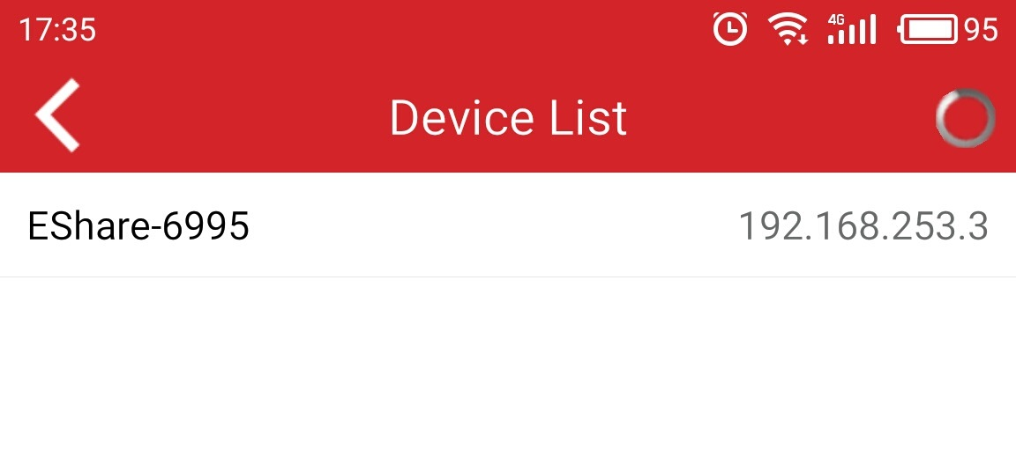
- Wireless Push
Click on the Android client file, can push to large-screen device to play, including music, video, pictures, office documents, PDF, e-books, APK and so on.
Click this button, you can access the device list
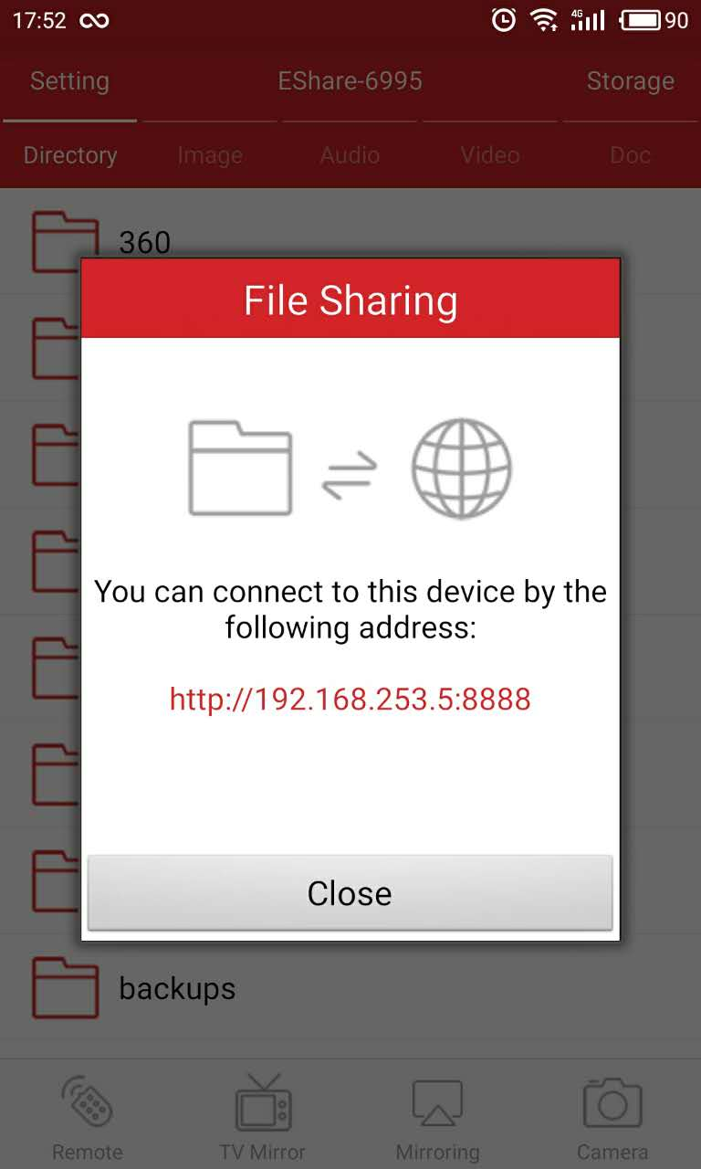
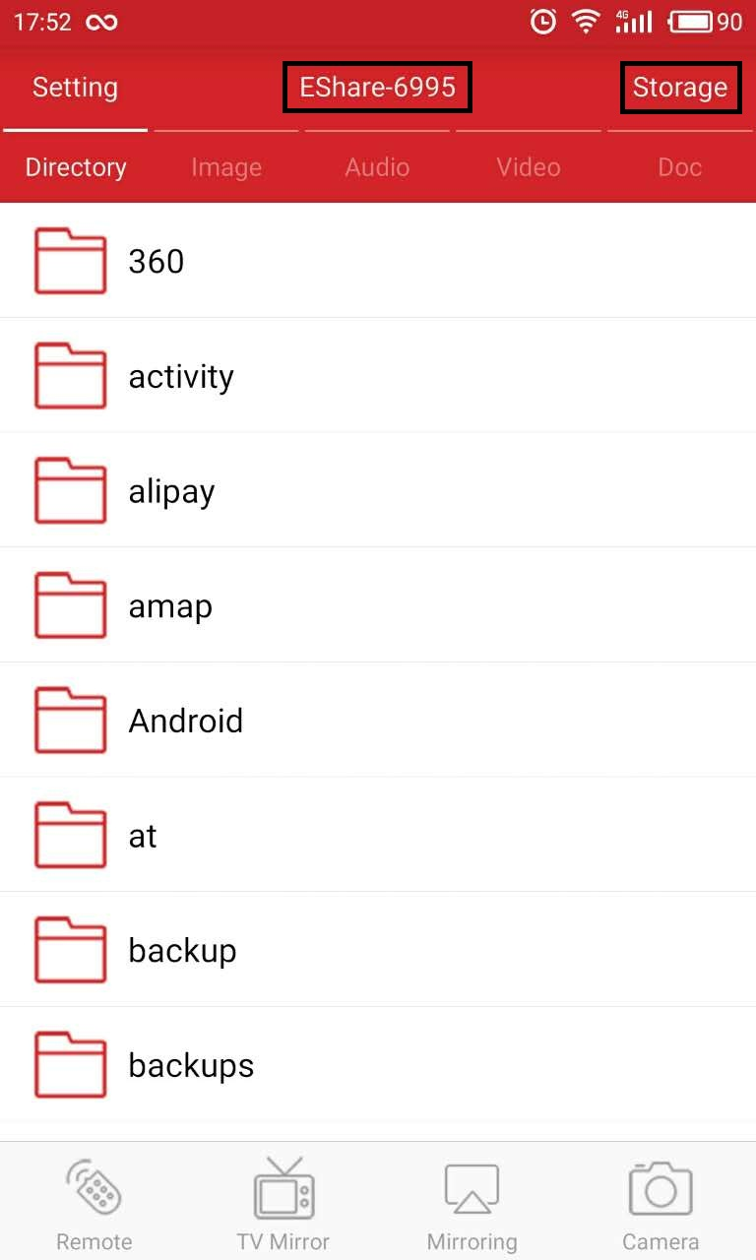
Click this button, you can achieve file sharing

- Wireless Screen
Click the "Mirroring" button of client, you can wirelessly send the Android device's screen to large-screen device.
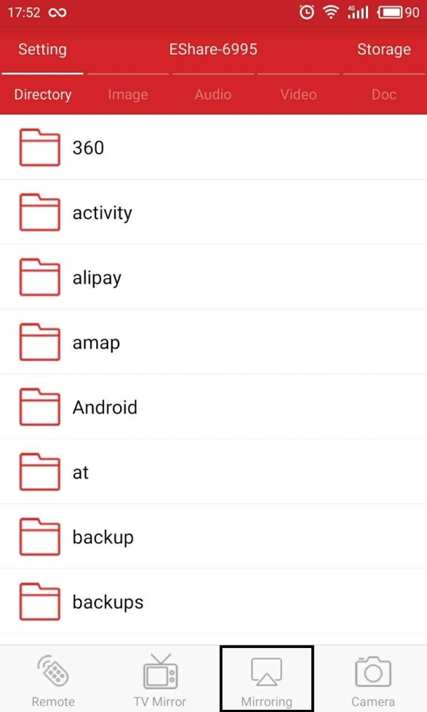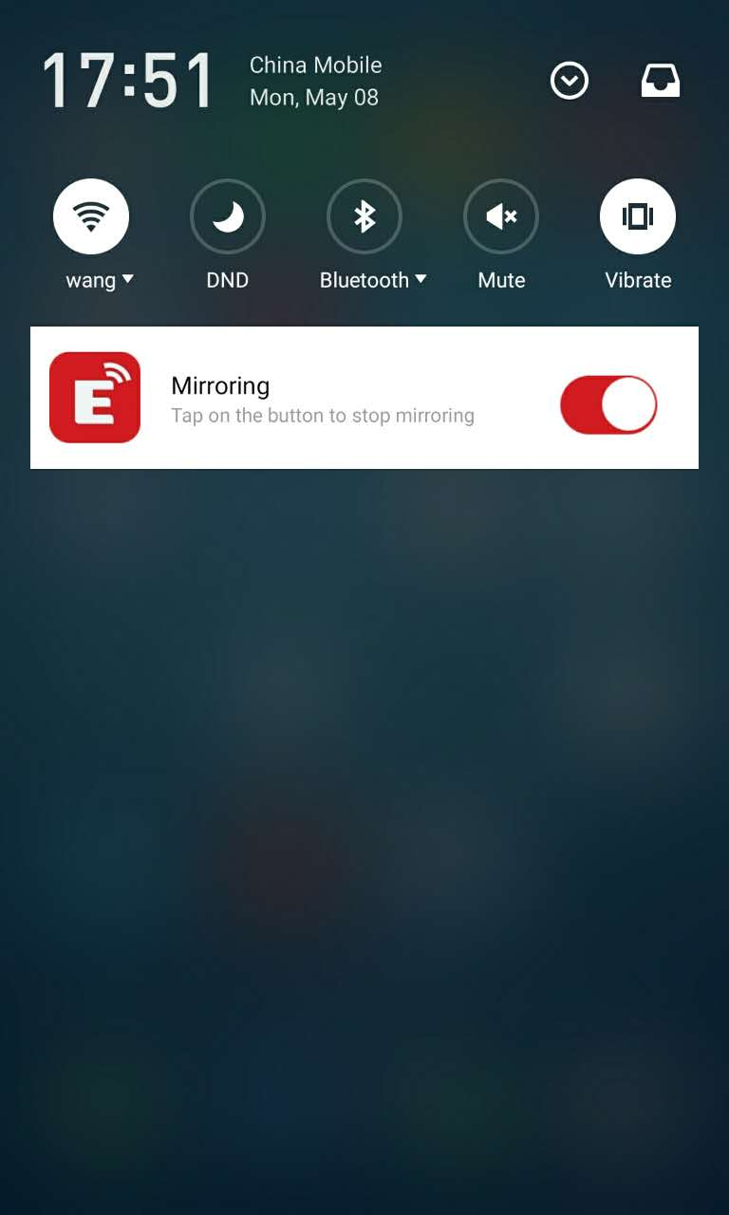

- Remote
In the EShare application click on the "Remote" button, you can use your phone as the wireless mouse, remote control, keyboard, air mouse and so on.
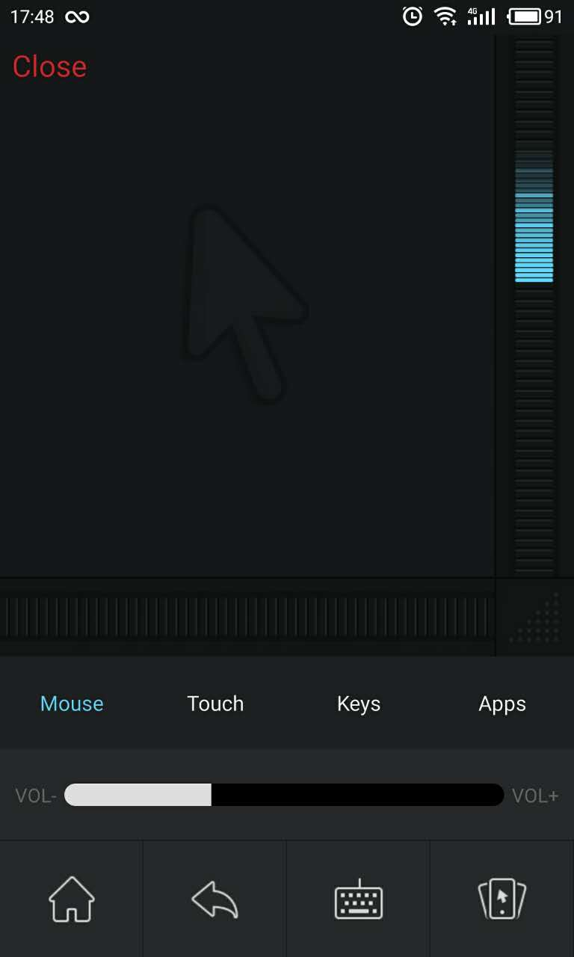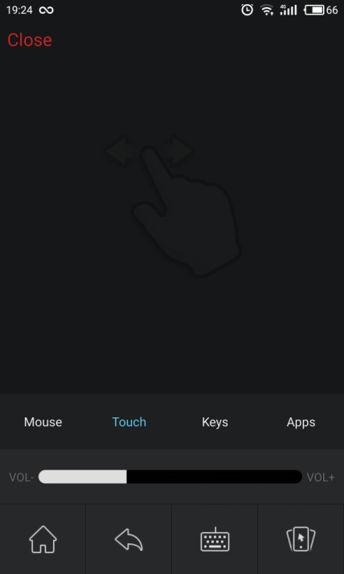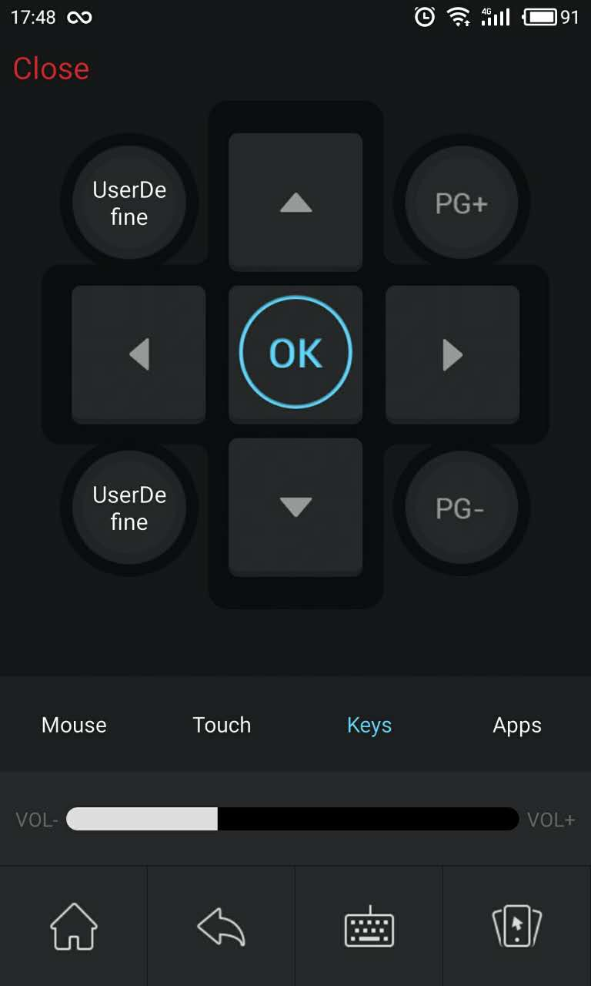
Mouse Touch Key

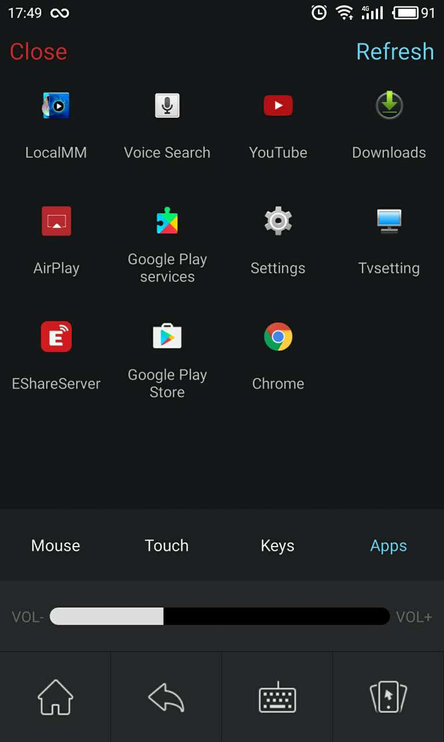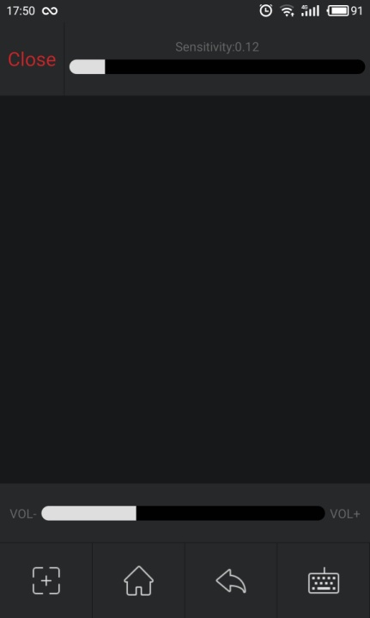
Apps Air Mouse

- TV Mirror
In the EShare application click on the "TV Mirror" button, you can make large-screen device real-time transmission to the phone. At the same time the phone to become large-screen device touchpad, you can directly on the phone on large-screen device for multi-touch.
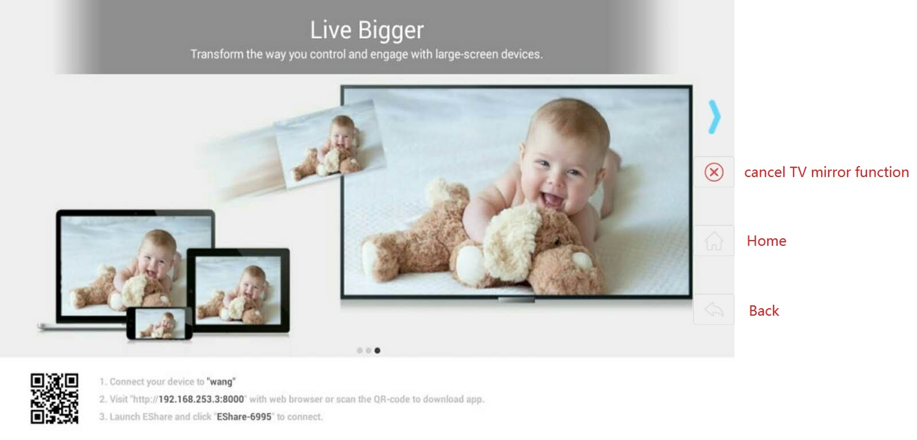

- Wireless Camera
In the EShare application, click the "Camera" button, you can transfer the picture and sound to large-screen device in real time.
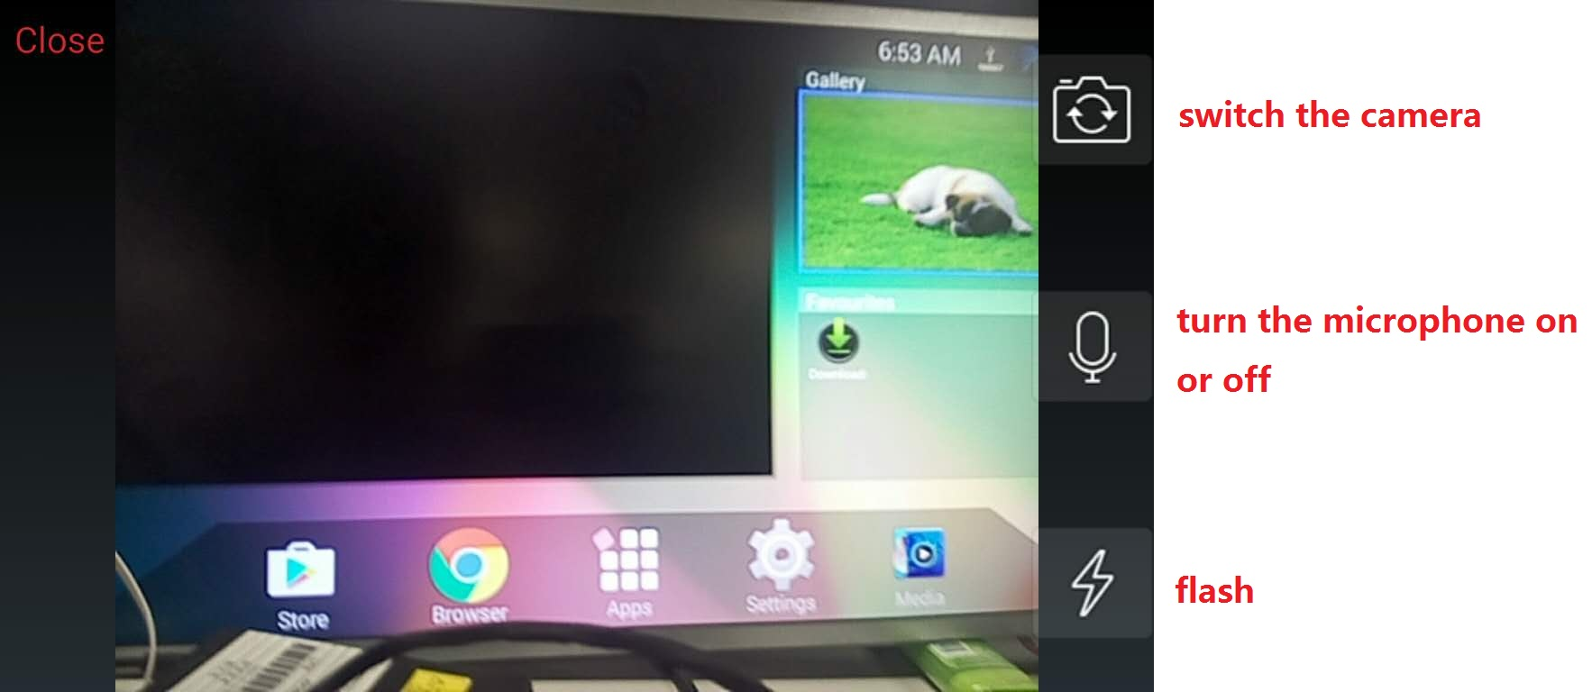

- Share files from other apps to the large-screens device
In other applications, you can share the file through the EShare display to large-screen device.
